Pps

-MINI PROJECT

#include <stdio.h>

int main()

{

int a;

printf("------JANUARY 2022------\n");

printf(" Su Mo Tu We Th Fr Sa\n");

for(a =1;a<32;++a){

if(a==1){

printf(" %2d\n",a);

}

else if(a%7==1){

printf(" %2d\n",a);

}

else {

printf(" %2d",a);

}

}

return 0; }

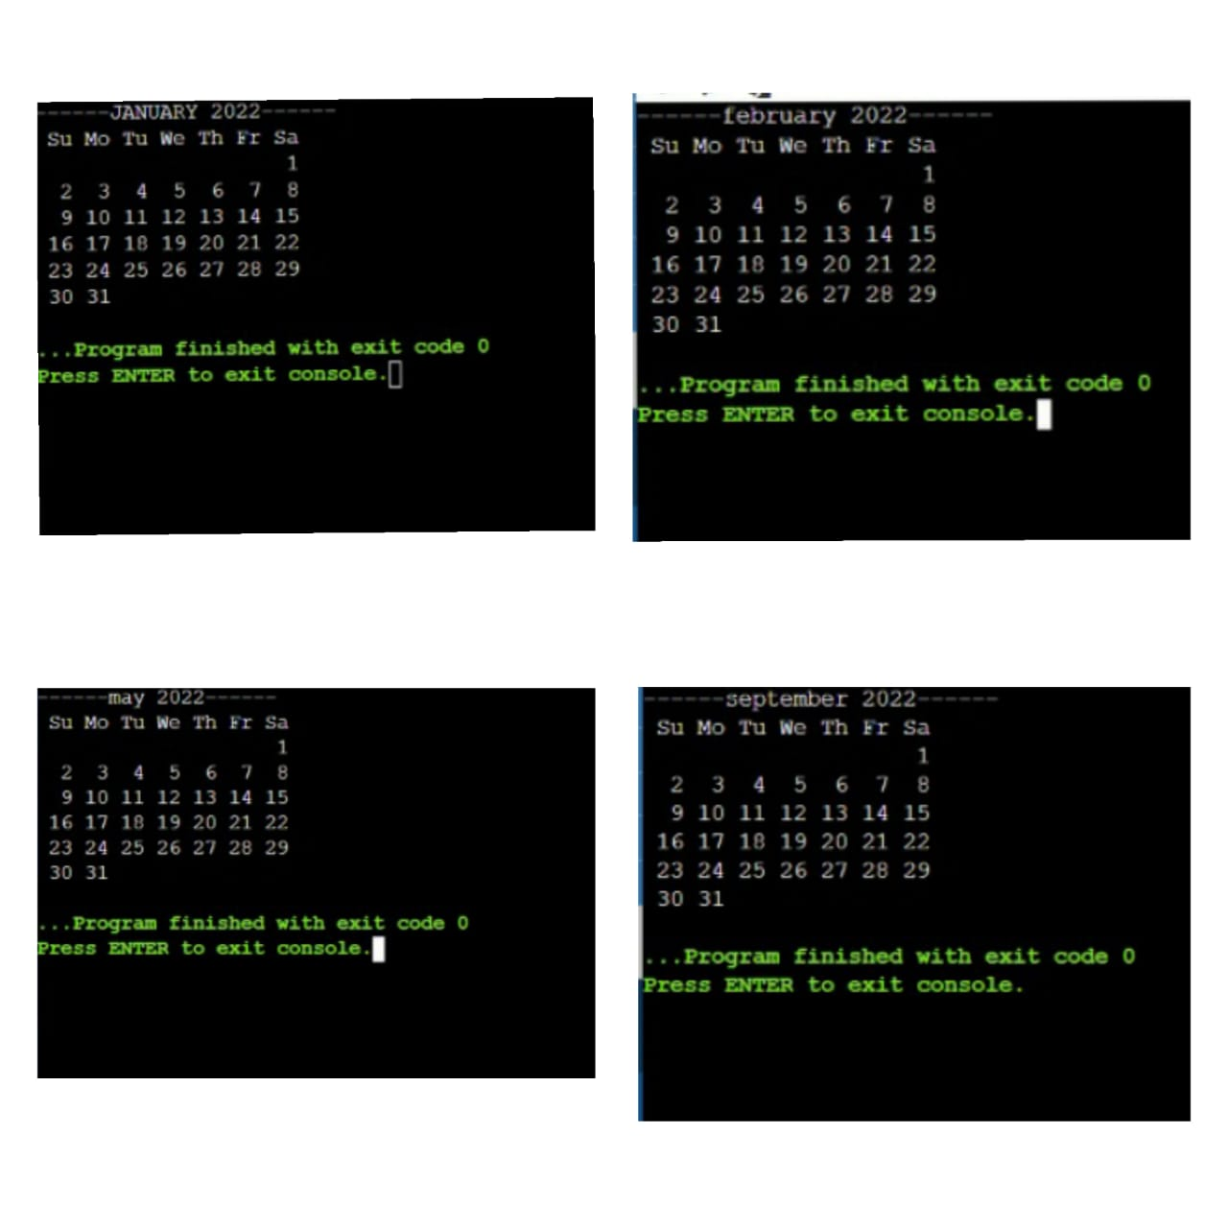

DONE BY: ABINAYASRI CHANDRASEKARAN